**Department of Artificial Intelligence**

**College of Computer and Cyber Sciences**

***Introduction to EON-XR***

1. **Objectives**

By the end of this lab, students will:

* Apply EON-XR in augmented reality.
* Role-play an AI conversation.
* Add interactions to a 3D model.
* Create a sequence of interactions on a 3D model.

1. **Lab Requirements**

* **Software:** 
  1. **EON-XR Account:** Students must have an active account on EON-XR.

([EON-XR - Sign In](https://core.eon-xr.com/Identity/Account/Login))

* 1. **EON-XR App:** The EON-XR application should be downloaded and installed on the student device.

1. **Key Concepts**

* **What is Augmented Reality (AR)?**

Augmented Reality (AR) overlays digital elements like images, sounds, and 3D objects onto the real world, enhancing how users perceive their surroundings. Unlike VR, which creates a fully virtual space, AR blends digital content with reality, commonly accessed via smartphones, tablets, or AR glasses for gaming, education, and retail.

1. **Preparation and Setup**
   1. **EON-XR App:** Download EON-XR on a camera-enabled device (phone, tablet, or iPad)
   2. **EON-XR Account:** Log-In to your EON-XR account on your device.
2. **Activities**

In this lab, students will engage in advanced interactions within EON-XR by integrating AI-driven conversations, applying augmented reality, and developing interactive 3D content.

* **Exercise 1: Role-Playing with AI Conversation.**

In this exercise, students will create a conversation scenario with an AI persona.

Step 1: After opening your app, from the four options choose “Soft Skills - AI conversation”.

Step 2: Place your **AI persona** into the environment.

Step 3: Choose the conversation sector, then the conversation topic.

Step 4: Select an **image** to use as the **thumbnail** and place it into the environment.

Step 5: After the AI assistant finishes its explanation, click the “Continue” button.

Step 6: Choose a **scenario** to train on.

Step 7: Choose **Your Role** and the **AI Persona Role**.

Step 8: Choose the AI persona **personality** and **avatar**.

Step 9: Now you can start by pressing “Start” button.

Step 10: Have a chat with your AI persona.

Step 11: When you are done, press the **Flag icon**.

Step 12: Now you can see your **overview chart** and more other options (Screenshot the overview chart into the document).

Step 13: Now exit using the “X” button on the top left (saving is optional).

* **Exercise 2: Adding Interactions on a 3D Model.**

In this exercise, students will create interactive elements on a 3D model to enhance engagement.

Step 1: After opening your app, from the four options choose “Create - Guided Xperience”.

Step 2: Select an **AI persona** and add it to your environment.

Step 3: Use the **End wizard symbol** down in the middle to cancel wizard mode.

Step 4: Add a **Car 3D object** to the environment.

Step 5: Use your **fingers** to adjust the size and direction to your liking.

Step 6: Add a **Pole 3D object** a little away from the car.

Step 7: Add the **Move Interaction** to the car:

* Making the car move toward the Pole.
* Select **Part trigger** to be the car.
* Save it.

Step 8: Add the **Smoke Interaction** to the car:

* Making the car hood looks like it's smoking.
* Select **Part trigger** to be the car hood.
* Save it.

Step 9: Repeat previous step using **Fire Interaction**.

Step 10: Add **Sequence Interaction** to the car:

* Using the plus icon, add the **Move Interaction**, the **Smoke Interaction**, then the **Fire Interaction**.
* Select **Part trigger** to be the car.
* Save it.

Step 11: Use the **View in Play mode icon** to preview your work.

Step 12: Save the environment into your EON-XR workspace.

1. **Submission**

Students should follow these steps to submit their work:

* Use the **"Share"** option located above the lesson in the EON-XR app.

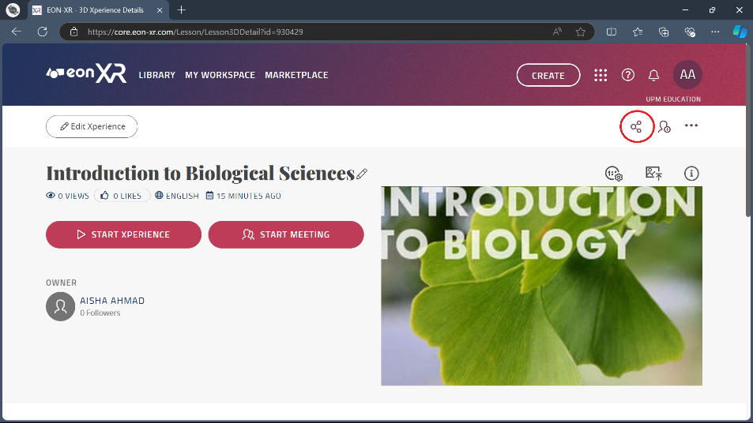

* **Copy the link** provided for your lesson.

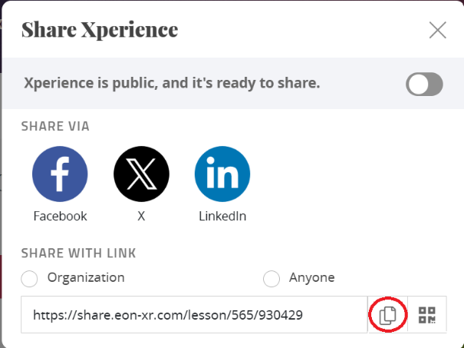

* **Paste the link** into a Word document.



**Add Your Link Here:**

1. **References**

[Metaverse Builder - EON-XR User Guides documentation](https://docs.eon-xr.com/HTML/Mobile/metaverseBuilder.html#procedures-user-guide)

[EON-XR: Revolutionizing Simulations with AI-Powered Interactions and Sound](https://www.youtube.com/watch?v=iH1wrSJh3ss)